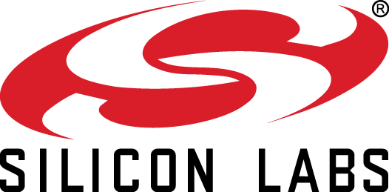
Corporate Giving Program Guidelines
The corporate giving program at Silicon Labs is primarily focused on education, specifically science, technology, engineering and math (STEM).
Galas, dinners and events will not be sponsored except for those at organizations with a member of our executive team serving on their Board of Directors. Silicon Labs does not support Capital Campaigns.
To have your organization considered for a Silicon Labs grant, send the completed application below and additional required documentation to jackie.padgett@silabs.com. Grant requests are reviewed within 30 days of receipt. Incomplete applications will not be considered.
Silicon Labs Nonprofit Funding Application:
- Organization name:
- Organization website:
- Organization EIN number:
- Organization phone number:
- Contact name, number, email address:
- Organization mission statement:
- Population is served by your organization:
- Annual number of people served:
- Description of services:
- Has Silicon Labs supported your organization in the past? If yes, please list amount given each year.
- Funding amount requested:
- Purpose of the funding, event or program:
- Brief description of the project (needs), specific goals and objectives:
- Date of event or program and total projected cost (if applicable):
- How will the impact or expected outcomes of your activities be measured? (limit 500 words)
- Are their opportunities for employee engagement?
- Are there any opportunities for public recognition of this gift?
NOTE: All applications should include the following documents:
- EIN/501c3 documentation
- Copy of latest annual report
- List of Board of Directors
- Supporting documents (optional)

